Title*: | Video User Experience Optimization via MEC - A Service Aware RAN MEC PoC
from Source*: | Intel UK Corporation
Contact: | Soo Jin Tan, Leifeng Ruan, Caroline Chan, Valerie Young, Cahill Joe
input for Committee*: | MEC IEG
Contribution For*: | Decision | X
 | Discussion
 | Information
Submission date*: | 2015-09-28
Meeting & Allocation:
Relevant WI(s), or deliverable(s):

Decision/action requested: Please approve

ABSTRACT: This is a MEC PoC Submission about video user experience optimization based on MEC, under the collaboration between Intel, China Mobile Communication Corporation and iQiYi

PoC Proposal

1 PoC Project Details

1.1 PoC Project
PoC Number (assigned by ETSI):
PoC Project Name: Video User Experience Optimization via MEC - A Service Aware RAN PoC
PoC Project Host: Intel UK Corporation
Short Description: Through the Video UE Optimization application running on the MEC server, the MEC application is able to recognize which are the paid video streams from the content provider. From there, the MEC application will assign higher priority to those video streams by ensuring higher bit rate. As a result, the paid subscribers will have a more guaranteed user experience when streaming video from the designated content provider.

1.2 PoC Team Members
 | Organisation name | ISG MEC participant  (yes/no) | Contact (Email) | PoC Point of Contact  (*) | Role (**) | PoC Components
1 | Intel UK Corporation | Yes | Soo Jin Tan  Soo.jin.tan@intel.com | X | Infrastructure Provider | MEC Test Bed  MEC Application
2 | China Mobile Communication Co., Ltd Research Institute | No | Yan Tao Han  hanyantao@chinamobile.com |  | Service Provider
3 | iQiYi | No | Ke Yu  yuke@qiyi.com |  | Content Provider | CDN Network
(*) Identify the PoC Point of Contact with an X.
(**) The Role will be network operator/service provider, infrastructure provider, application provider or other.

All the PoC Team members listed above declare that the information in this proposal is conformant to their plans at this date and commit to inform ETSI timely in case of changes in the PoC Team, scope or timeline.

1.3 PoC Project Scope

1.3.1 PoC Topics
PoC Topics identified in this clause need to be taken for the PoC Topic List identified by ISG MEC and publicly available in the MEC WIKI. PoC Teams addressing these topics commit to submit the expected contributions in a timely manner.
PoC Topic Code | PoC Topic Description | Related WG/WI | Expected Contribution | Target Date
PT#01 | Demonstration of MEC Service Scenario - Intelligent Video Acceleration Service Scenario | MEC-004 Service Scenarios (GS MEC-IEG 004) - Mobile Edge Computing (MEC) Service Scenarios | Technical Report providing the lessons learnt and technical information requested by PT#01 | Q1-2016

1.3.2 Other topics in scope
List here any additional topic for which the PoC plans to provide input/feedback to the ISG MEC.
PoC Topic Code | PoC Topic Description | Related WG/WI | Expected Contribution | Target Date
A
B
<…>

A.1.4 PoC Project Milestones
PoC Milestone | Milestone description | Target Date | Additional Info
P.S | PoC Project Start | April-2015
P.D1 | PoC Demo 1 – Video User Experience Optimization | July-2015 | MWC Shanghai 2015
P. D2 | PoC Demo 2 – Video Content Delivery from MEC Server | July-2015 | MWC Shanghai 2015
P. D3 | PoC Demo 3 - Video User Experience Optimization | Sep-2015 | China ICT Expo 2015
P. D4 | PoC Demo 4 – Video Content Delivery from MEC Server | Sep-2015 | China ICT Expo 2015
P. D5 | PoC Demo 5 – Video User Experience Optimization | Q4-2015 | ETSI Webinar
P. D6 | PoC Demo 6 – Video Content Delivery from MEC Server | Q4-2015 | ETSI Webinar
P. D7 | PoC Demo 7 – Video User Experience Optimization | Q1-2016 | TBD
P. D8 | PoC Demo 8 – Video Content Delivery from MEC Server | Q1-2016 | TBD
P.C1 | PoC Expected Contribution 1 | Q1-2016
P.R | PoC Report | Q1-2016
P.E | PoC Project End | Q1-2016

NOTE: Milestones need to be entered in chronological order.

1.5 Additional Details
For example, URL, planned publications, conferences, etc.

A.2 PoC Technical Details

A.2.1 PoC Overview
Video user’s experience has become increasingly important especially when ~70% of mobile traffics are consist of video traffic. However, wireless access network has always been the bottleneck since it lacks of visibility into the video packets. Furthermore, the content provider will continue to treat the mobile network as a dump pipe of data transmission since it doesn’t offer much value added benefits to their content delivery.
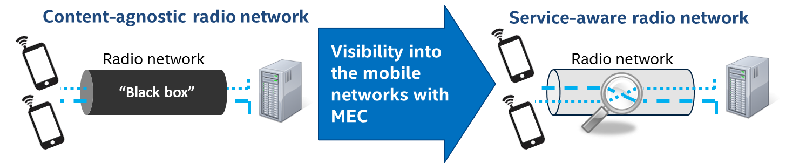
The Video User Experience Optimization application, running on the MEC server is able to recognize the Content Provider or OTT’s video streams among the premium members and normal members (free). The premium members who have paid for the subscriptions to the content provider, will be given the prioritization bandwidth when the mobile network is congested. Thus the paid subscriber of content provider will enjoy a more guaranteed user experience and beneficial from the MEC application.
In addition to that, the POC also showcased how to maximize the utilization of shared wireless resources in order to improve ROI. At the end, this technology innovation will potentially generate new revenue stream for both network provider and content provider.
This an example of Service Aware RAN, same principle can also be applied to other similar usage model such as financial transaction, webpage browsing, mobile gaming and etc. The RAN with MEC is able to recognize these services and make appropriate actions.

A.2.2 PoC Architecture
This end-to-end PoC consist of the UEs, eNB, MEC Server, EPC and connected to the content provider’s (iQiYi) CDN network. The connection between UEs and eNB is OTA via Remote Radio Head attaching to the eNB.
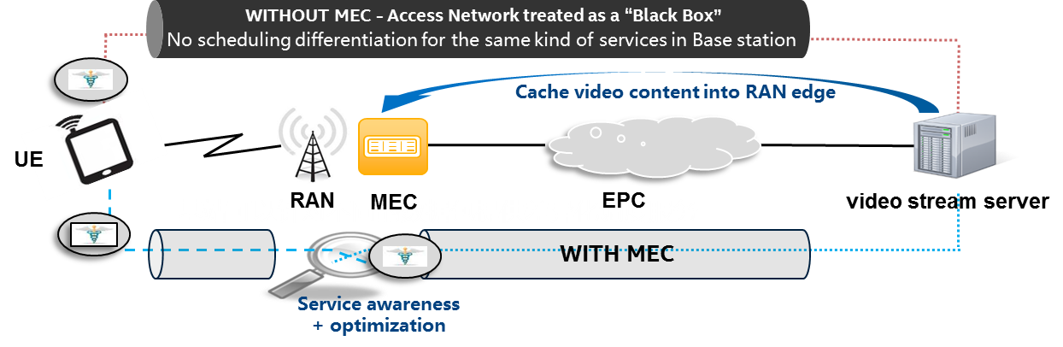
Firstly, UEs will issue HTTP request for video contents from the content provider CDN network either by the mobile application or by visiting the website. When the video contents begin to stream from the video server to the UEs, the MEC application will then perform user packet analysis/inspection to identify each the streams. With that, it’s able to differentiate the paid subscribers and normal (unpaid) subscribers based on the info provided by the content providers and cross match it with their respective IP addresses. When mobile networks experiences traffic congestion, the MEC application will make the decision to prioritize the video packets of the paid users (based on IP address) by allocating the high bit rate.
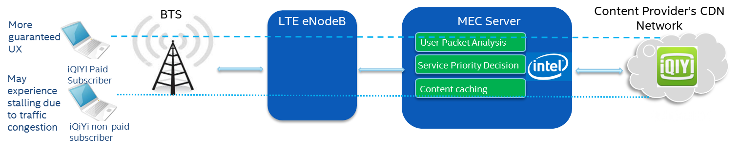

A.2.3 Additional information

