Title*: | Edge Video Orchestration and Video Clip Replay via MEC
from Source*: | Nokia Networks and Everything Everywhere
Contact: | Dirk Lindemeier, Uwe Rauschenbach (Nokia Networks),  Matt Stagg (Everything Everywhere)
input for Committee*: | MEC IEG
Contribution For*: | Decision | X
 | Discussion
 | Information
Submission date*: | 2015-11-22
Meeting & Allocation:
Relevant WI(s), or deliverable(s):

Decision/action requested: Please approve

ABSTRACT: This is an MEC PoC submission about real time distribution of video streams in stadiums and other event venues, under the collaboration between Nokia, EE, and Smart Mobile Labs.

PoC Proposal

1 PoC Project Details

1.1 PoC Project
PoC Number (assigned by ETSI):
PoC Project Name: Edge Video Orchestration and Video Clip Replay via MEC
PoC Project Host: Nokia
Short Description: Through the Edge Video Orchestration application running on the MEC server, the end user is able to receive live video streams from professional stadium cameras in real time. The user can choose the camera angle and view video replays provided locally. All media is produced, injected and played out locally, without the need to modify core network elements. Backhaul and core capacity is not impacted.

1.2 PoC Team Members
 | Organisation name | ISG MEC participant  (yes/no) | Contact (Email) | PoC Point of Contact  (*) | Role (**) | PoC Components
1 | Nokia | Yes | Dirk Lindemeier  dirk.lindemeier@nokia.com  Uwe Rauschenbach  uwe.rauschenbach@nokia.com | X | Infrastructure Provider | MEC Server  End-to-end integration
2 | EE | Yes | Matt Stagg  matt.stagg@ee.co.uk | X | Service Provider | LTE network
3 | Smart Mobile Labs | No | Klaus Nagora  klaus.nagora@smartmobilelabs.de |  | Application provider | MEC application
(*) Identify the PoC Point of Contact with an X.
(**) The Role will be network operator/service provider, infrastructure provider, application provider or other.

All the PoC Team members listed above declare that the information in this proposal is conformant to their plans at this date and commit to inform ETSI timely in case of changes in the PoC Team, scope or timeline.

1.3 PoC Project Scope

1.3.1 PoC Topics
PoC Topics identified in this clause need to be taken for the PoC Topic List identified by ISG MEC and publicly available in the MEC WIKI. PoC Teams addressing these topics commit to submit the expected contributions in a timely manner.
PoC Topic Code | PoC Topic Description | Related WG/WI | Expected Contribution | Target Date
PT#01 | Demonstration of MEC Service Scenario (new scenario) | MEC-IEG004 | Technical Report describing the Service Scenario and providing the lessons learnt and technical information requested by PT#01 | Q1 2016

1.3.2 Other topics in scope
List here any additional topic for which the PoC plans to provide input/feedback to the ISG MEC.
PoC Topic Code | PoC Topic Description | Related WG/WI | Expected Contribution | Target Date
n/a

1.4 PoC Project Milestones
PoC Milestone | Milestone description | Target Date | Additional Info
P.S | PoC Project Start | Oct 2015
P.D1 | PoC Demo at Connected Stadium Summit, Wembley Stadium, London | 24-25 Nov2015
P.D2 | Webinar | Q1-2016
P.C1 | PoC Technical Report | Q1-2016
P.R | PoC Report | Q1-2016
P.E | PoC Project End | Q1-2016

NOTE: Milestones need to be entered in chronological order.

1.5 Additional Details

2 PoC Technical Details

2.1 PoC Overview
Stadiums are stages for operators to showcase network performance and latest mobile services. Stadium owners (or local sport clubs as tenants) have a strong interest in making the visitor’s experience as pleasant as possible, and drive revenues beyond ticket sales.

Being able to receive live feeds from cameras mounted close to the playing field (e.g. behind the goals), replays, and additional player context on mobile devices is a strong use case for both operators and stadium owners. Practical experience shows, however, that even LTE networks deliver such content with seconds rather than milliseconds of delay, and considerable strain is put on the backhaul network. By deploying an MEC server these challenges can be addressed, as will be proven with the means of the Edge Video Orchestration PoC deployed in Wembley Stadium, London, UK.

The Edge Video Orchestration application running on the MEC server creates a point for real time content to be injected to the local LTE network at the venue. Furthermore, the application provides the logic for distributing the live video feeds received from the local production room to local spectators, in a highly efficient manner. End users are able to dynamically select between different streams offered, whereby previews are displayed with a low screen resolution, and the main view is displayed with the highest resolution possible. Compared with available cloud based solutions MEC delivers the following benefits:
- Latency: live feeds viewed on the LTE device are in sync with what the stadium visitor sees directly, that is, the difference is smaller than what the human eye can realize. Such low latency is not only achieved by shortening the data transmission path, but by optimizing the complete chain (incl. encoders, production, streaming) from the cameras to the device.
- Backhaul capacity: playing out the live feeds and replays out locally puts no additional strain on the backhaul network and upstream core network components, such as, S/PGW, load balancers, optimizers, firewalls, etc.
- Content rights: as traffic is kept entirely local by the physical solution design content distribution rights can be arranged more easily.
- Real time context: aside of camera angles also other event context can be provided in real time, such as, player positions viewed from straight above, player speeds, etc. Also audio (“ref mike”) could be included. This, however, is outside the scope of the proposed PoC.

As most LTE devices do not support eMBMS yet the proposed PoC implements unicast streaming, which would saturate the available LTE air interface capacity once stadium visitors start using the Edge Video Orchestration application on a grand scale. The addition of eMBMS, implemented by the means of eMBMS core network components running on the MEC server, is therefore being considered for a subsequent PoC.

The PoC will use real LTE terminals. Nokia Networks will upgrade Everything Everywhere’s network around the stadium with MEC capabilities to provide the service.

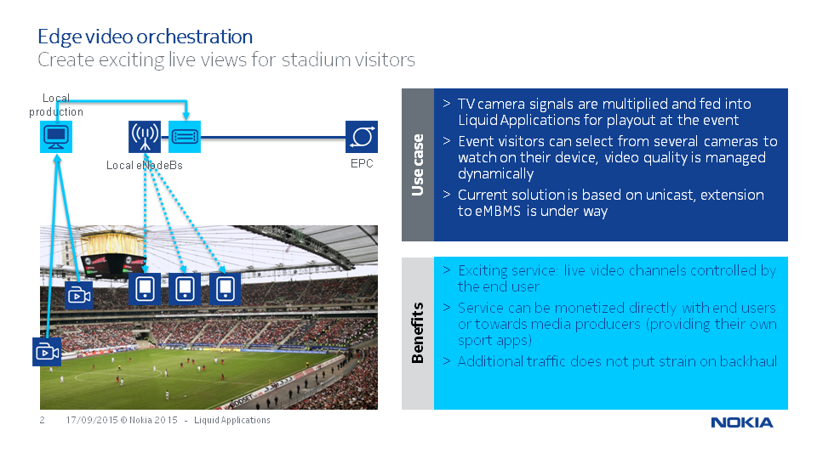

2.2 PoC Architecture
This PoC consists of an eNodeB, MEC Server, EPC, several professional TV cameras (with high-speed encoders), a clip replay solution, and end user devices running an app for viewing the live and replay contents.

On the production side the raw camera HDSDI signals are fed to encoders and then connected into the MEC Server. In parallel the signals are fed into the replay solution. On the distribution side the app running on the LTE device is used for accessing both the live and the replay content, with users being able to select dynamically. All media is played out locally.

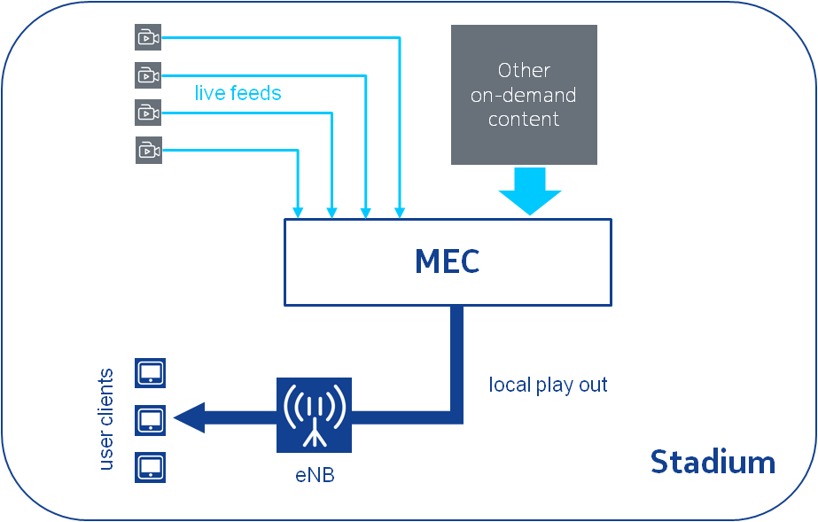

2.3 Additional information

