Title*: | POC Proposal: Enterprise services
from Source*:
 | ADVA Optical Networking
Contact: | Michael Rabinovich mrabinovich@advaoptical.com
 | Saguna Networks
Contact: | Danny Frydman danny@saguna.net
input for Committee*: | MEC IEG
Contribution For*: | Decision | X
 | Discussion
 | Information
Submission date*: | 2016-06-22
Meeting & Allocation: | MECIEG#22
Relevant WI(s), or deliverable(s):

Decision/action requested: Please approve

ABSTRACT: This is an MEC PoC submission about MEC Enterprise services

PoC Proposal

1 PoC Project Details

1.1 PoC Project
PoC Number (assigned by ETSI):
PoC Project Name: Enterprise Services
PoC Project Host: Adva Optical
Short Description: Use of MEC for Enterprise by implementation of a local breakout for the enterprise users

1.2 PoC Team Members
 | Organisation name | ISG MEC participant  (yes/no) | Contact (Email) | PoC Point of Contact  (*) | Role (**) | PoC Components
1 | Saguna | Yes | Danny Frydman  danny@saguna.net |  | Infrastructure Provider  Application provider | MEC Platform  Local Breakout application
2 | ADVA Optical Networking | Yes | Michael Rabinovich  mrabinovich@advaoptical.com | X | Infrastructure Provider | Virtualization infrastructure and Packet forwarding
3 | Bezeq International | No | Elad Hefetz EladH@bezeqint.co.il |  | Service Provider | POC testbed, POC venue
(*) Identify the PoC Point of Contact with an X.
(**) The Role will be network operator/service provider, infrastructure provider, application provider or other.

All the PoC Team members listed above declare that the information in this proposal is conformant to their plans at this date and commit to inform ETSI timely in case of changes in the PoC Team, scope or timeline.

1.3 PoC Project Scope

1.3.1 PoC Topics
PoC Topics identified in this clause need to be taken from the PoC Topic List identified by ISG MEC and publicly available in the MEC WIKI. PoC Teams addressing these topics commit to submit the expected contributions in a timely manner.
PoC Topic Code | PoC Topic Description | Related WG/WI | Expected Contribution | Target Date
PT#01 | Demonstration of MEC Service Scenario “Enterprise deployment of MEC” | MEC-IEG004 | Technical Report describing the Service Scenario and providing the lessons learnt and technical information requested by PT#01 | Q2 2017

1.3.2 Other topics in scope
List here any additional topic for which the PoC plans to provide input/feedback to the ISG MEC.
PoC Topic Code | PoC Topic Description | Related WG/WI | Expected Contribution | Target Date
n/a

1.4 PoC Project Milestones
PoC Milestone | Milestone description | Target Date | Additional Info
P.S | PoC Project Start | June 30, 2016
P.D1 | PoC Demo at MEC World Congress | September 2016 | PoC Demo set-up
P.D2 | PoC Live Demo at chosen Enterprise | Q1-2017 | Installation of the MEC host with MEC Platform and Enterprise Break-out application in the friendly Enterprise and running for a while
P. C1 | PoC Expected Contribution | Q2-2017 | PoC Contribution on PT#01
P.R | PoC Report | Q2-2017
P.E | PoC Project End | Q2-2017

NOTE: Milestones need to be entered in chronological order.

1.5 Additional Details

2 PoC Technical Details

2.1 PoC Overview
This overview is based on ETSI GS MEC 002/Annex A.22.
Mobile devices are gradually replacing fixed communications hardware, laptop software, and office services in the enterprise market by leveraging native desktop interfaces as well as additional value-added apps. This is a replication of trends in the consumer market. Since about 2010, the consumer market has seen many devices and physical world technologies replaced by smartphone and tablet hardware and software and internet cloud platforms.
Once robust coverage and capacity are available indoors, the enterprise can start to move towards a truly mobile office where the business tools are migrated into the mobile devices and there is ubiquitous access to cloud-based business tools. The presence of a mobile edge deployment of Small Cells on enterprise premises makes it a natural candidate for support of enterprise applications in the mobile edge.
The following figure describes a Mobile Edge Computing-based breakout to an enterprise network, enabling employees using smartphones and tablet PCs to enjoy a fast broadband connection directly to the enterprise LAN.
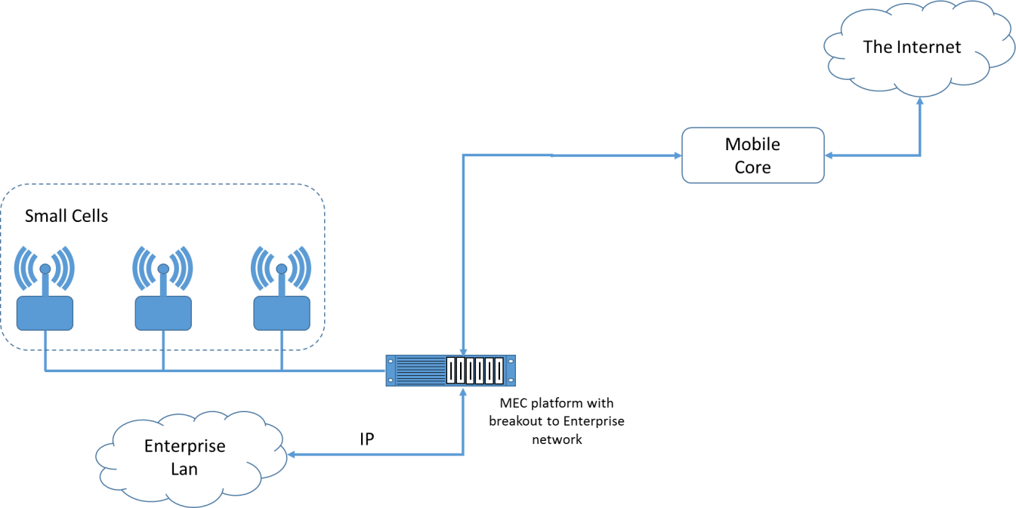
Figure 1: Mobile Edge Computing based breakout to an enterprise network

2.2 PoC Architecture
This end-to-End POC consists of the UEs attached to the Enterprise Wireless Access Network, Enterprise Domain server and CPE with MEC host Infrastructure running MEC Platform services and ME Enterprise App.
When the Enterprise ME Application is not activated Enterprise Users will reach Enterprise server through the Provider NW experiencing higher delay and poor service quality, in addition the Provider NW will be overloaded with the excessive bandwidth.
In case of Enterprise ME Application is activated the UEs identified as the Enterprise users would reach Enterprise server directly without going through Provider NW

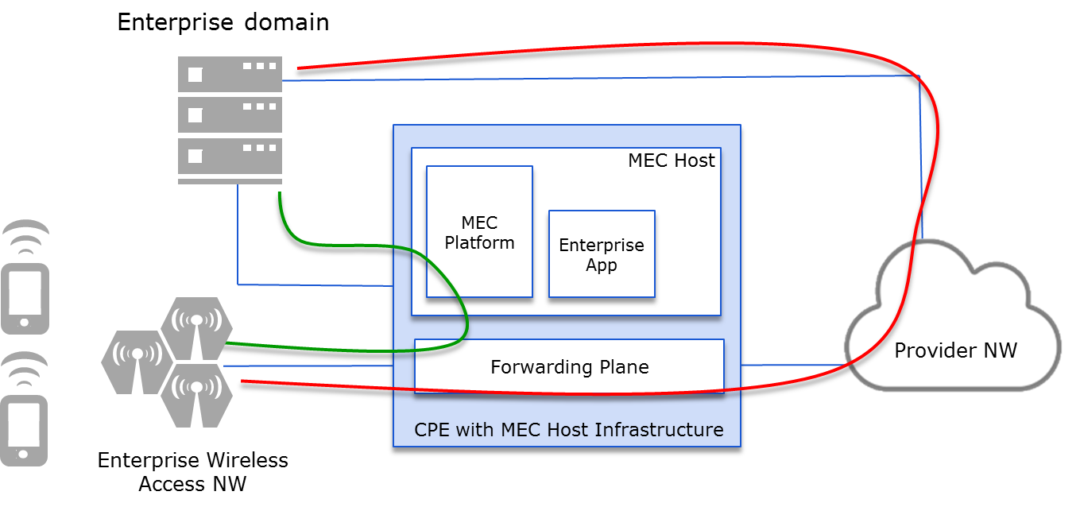

2.3 Additional information

