Title*: | POC: Healthcare – Dynamic Hospital User, IoT and Alert Status management
from Source*: | Quortus Limited
Contact: | Paul Trubridge
input for Committee*: | MEC IEG
Contribution For*: | Decision | X
 | Discussion
 | Information
Submission date*: | 2016-06-30
Meeting & Allocation: | MECIEG#21 -
Relevant WI(s), or deliverable(s): | DGS/MEC-IEG004 ; DGS/MEC-IEG005

Decision/action requested: Please approve

ABSTRACT: This POC considers a typical ‘Healthcare’ use-case where a Hospital is able to assign a cellular access hierarchy (using network slicing) and open access (at the edge) to local systems depending on managed access rights. It also demonstrates dynamic network slicing based on Hospital ‘alert’ status

PoC Proposal

1 PoC Project Details

1.1 PoC Project
PoC Number (assigned by ETSI):
PoC Project Name: Healthcare – Dynamic Hospital User, IoT and Alert Status management
PoC Project Host: Quortus Ltd
Short Description: This POC considers a typical ‘Healthcare’ use-case where a Hospital is able to assign a cellular access hierarchy (using network slicing) and open access (at the edge) to local systems depending on managed access rights. It also demonstrates dynamic network slicing based on Hospital ‘alert’ status

1.2 PoC Team Members
 | Organisation name | ISG MEC participant  (yes/no) | Contact (Email) | PoC Point of Contact  (*) | Role (**) | PoC Components
1 | Quortus Ltd | Yes (member) | paul.trubridge@quortus.com | X | Application Provider
2 | Argela | No | Oguz.Sunay@argela-usa.com |  | Infrastructure Provider
3 | Turk Telecom | No | savas.tanyeri@turktelekom.com.tr |  | Network Operator
(*) Identify the PoC Point of Contact with an X.
(**) The Role will be network operator/service provider, infrastructure provider, application provider or other.

All the PoC Team members listed above declare that the information in this proposal is conformant to their plans at this date and commit to inform ETSI timely in case of changes in the PoC Team, scope or timeline.

1.3 PoC Project Scope

1.3.1 PoC Topics
PoC Topics identified in this clause need to be taken for the PoC Topic List identified by ISG MEC and publicly available in the MEC WIKI. PoC Teams addressing these topics commit to submit the expected contributions in a timely manner.
PoC Topic Code | PoC Topic Description | Related WG/WI | Expected Contribution | Target Date
PT01 | Demonstration of MEC Service Scenarios (new scenario) | MEC-004 Service Scenarios (GS MEC-IEG 004) - Mobile Edge Computing (MEC) Service Scenarios | Technical Report providing the lessons learnt and technical information requested by PT#01 | Dec 2016
PT03 | MEC Architecture | MEC003 | Technical report detailing C-Plane aware MEC architecture | 30/11/16

1.3.2 Other topics in scope
List here any additional topic for which the PoC plans to provide input/feedback to the ISG MEC.
PoC Topic Code | PoC Topic Description | Related WG/WI | Expected Contribution | Target Date

1.4 PoC Project Milestones
PoC Milestone | Milestone description | Target Date | Additional Info
P.S | PoC Project Start | 01/07/16
P.D1 | PoC Demo | 20/09/16 | MEC Congress, Munich
P.C1 | PoC Expected Contribution 1 | 30/11/16 | On MEC Service Scenarios (PT01)
P.C2 | PoC Expected Contribution 2 | 30/11/16 | On MEC Architecture (PT03)
P.R | PoC Report | 31/12/16
P.E | PoC Project End | 31/12/16

NOTE: Milestones need to be entered in chronological order.

1.5 Additional Details
POC show-cased at MEC Congress 2016.

2 PoC Technical Details

2.1 PoC Overview
MEC offers the ability to grant cellular users access to local Voice and Data services and integrate IoT devices into the local cellular network. Quortus has developed managed local IP breakout and PBX / VoLTE integration capabilities for MEC. Argela have developed Network Slicing based Radio Resource Management which can provide an enterprise with local control of LTE resources/bandwidth.
MEC can provide significant benefits in deployments in Hospitals where there are a mix of users (e.g. Medical Staff, Service Staff, Patients, Visitors, IoT, etc) requiring different levels of access to local infrastructure. Their access needs change as, for example, people come in and register as patients, and access priority changes as the hospital adopts ‘alert’ status. In this case, hospitals cannot rely on the MNO to manage access and ideally require integration with their local patient management and alert status systems.
This POC considers a typical ‘Healthcare’ use-case where a Hospital is able to assign a cellular access hierarchy (using network slicing) and open access (at the edge) to local systems depending on managed access rights. It also demonstrates dynamic network slicing based on Hospital ‘alert’ status.
The POC demonstrates the following:
- Local voice and data breakout services
- Different radio resource slices for different categories of user
- Dynamic hospital manged upgrading of users between categories
- Dynamic response to critical incident with modifications to radio resource allocations

Example use-cases for each user category are as follows:
- Staff
  - Best service and guaranteed radio resources
  - VoLTE support – integrated with PBX
  - Local data breakout – integrated with locally hosted services
  - High bandwidth M2M video calls supported
- Public
  - Basic cellular services – RAN extension for the MNO(s)
  - Low priority resource allocation – sacrificed if higher priority users require the bandwidth or in case of major incident
- Patient
  - Dynamically upgradable from public user – via token from reception and access portal
  - Returned to public access after timeout of access token
  - Higher priority than basic public user for resource allocation
  - Local PBX integration for in building calling (mobile handset becomes guest PBX extension)
  - Local data breakout for local services (e.g. CDN for films, appointment planning or information notice services)
- Critical IoT
  - High priority radio resources
  - Local breakout and M2M traffic flows to offload core network
- Low priority IoT
  - Lower priority radio resources
  - Sacrificed during major incident or overload situations
  - Local data breakout to offload core network.

Access to MNO and Local Services will be managed per user category as follows:
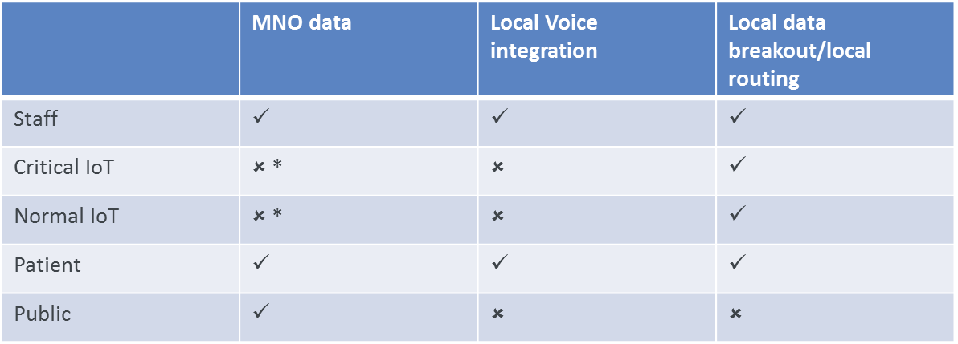
*Internet access denied to/from for security reasons

Three levels of ‘Alert’ status will be demonstrated as follows:
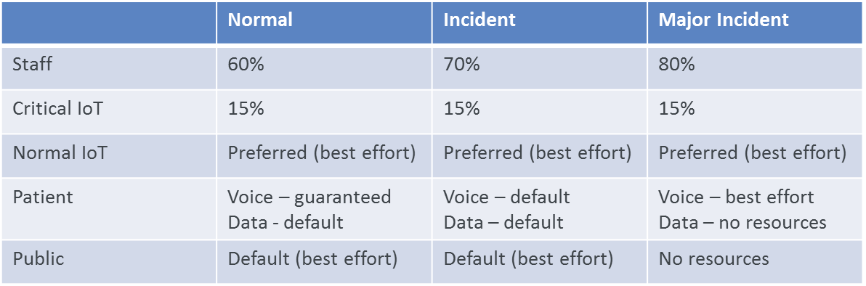

2.2 PoC Architecture

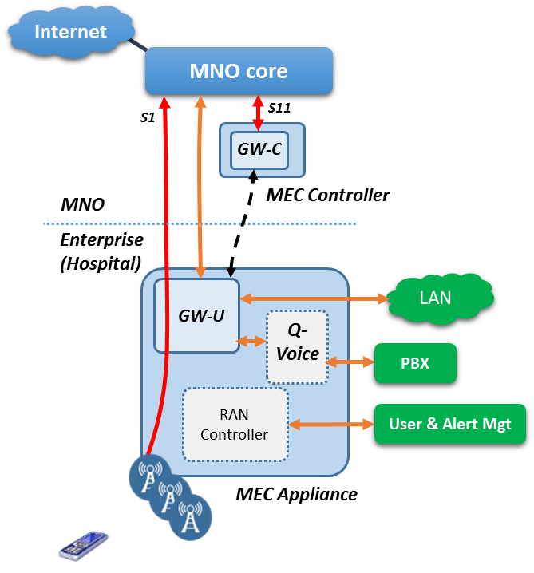

2.3 Additional information
This PoC, and its associated report, will address any benefits of a control plane aware MEC architecture over the current ETSI MEC user plane only approach.

