Title*: | POC Proposal: Multi-Service MEC Platform for Advanced Service Delivery
from Source*:
Contact: | Brocade Communications
 | Tim Epkes tepkes@brocade.com
Input for Committee*: | MEC IEG
Contribution For*: | Decision | X
 | Discussion
 | Information
Submission date*: | 2016-06-30
Meeting & Allocation: | MECIEG#22
Relevant WI(s), or deliverable(s):

Decision/action requested: Please approve

ABSTRACT: This is an MEC PoC submission about MEC Architecture and MEC Service Scenarios

PoC Proposal

1 PoC Project Details

1.1 PoC Project
PoC Number (assigned by ETSI):

PoC Project Name: Multi-Service MEC Platform for Advanced Service Delivery

PoC Project Host: Brocade Communications

Short Description: MEC requires more than just standardization, including the establishment of an interoperable ecosystem that continues to develop new use-cases for MEC. Through a single, unified infrastructure, NFV-O, and cloud orchestration system, this MEC PoC will demonstrate the ability to support multiple MEC platforms and applications residing on shared and common computing infrastructure, each providing a unique value-add on the traffic traversing platform. Traffic, by APN or IP address range, will be dynamically routed to select MEC platforms, which will then introduce unique sets of data analytics, traffic optimization and network applications, leveraging service function chaining, that enhance subscriber experience and operator visibility into network characteristics.

1.2 PoC Team Members
 | Organisation name | ISG MEC participant  (yes/no) | Contact (Email) | PoC Point of Contact  (*) | Role (**) | PoC Components
1 | Brocade Communications | Yes | Tim Epkes  tepkes@brocade.com | X | Infrastructure Provider | Brocade Virtual Services Platform, Brocade. Brocade Workflow Composer (Automation)
2 | Gigaspaces | No | Amir Levy  amir@gigaspaces.com |  | Infrastructure Provider | Cloudify MEC Orchestration
3 | Advantech | No | Eric van Vilet  eric.vanvilet@advantech.com |  | Infrastructure Provider | Advantech XLc Edge Computing Platform
4 | Saguna | Yes | Danny Frydman  danny@saguna.net |  | Infrastructure Provider / Application Provider | Saguna Open-RAN and applicable service use-cases
5 | Vasona | Yes | Rui Frazao  rfrazao@vasonanetworks.com |  | Infrastructure Provider / Application Provider | Vasona Smart Air and applicable service use-cases
6 | Vodafone | Yes | Guenter Klas  Guenter.Klas@vodafone.com |  | Service Provider
(*) Identify the PoC Point of Contact with an X.
(**) The Role will be network operator/service provider, infrastructure provider, application provider or other.

All the PoC Team members listed above declare that the information in this proposal is conformant to their plans at this date and commit to inform ETSI timely in case of changes in the PoC Team, scope or timeline.

1.3 PoC Project Scope

1.3.1 PoC Topics
PoC Topics identified in this clause need to be taken from the PoC Topic List identified by ISG MEC and publicly available in the MEC WIKI. PoC Teams addressing these topics commit to submit the expected contributions in a timely manner.
PoC Topic Code | PoC Topic Description | Related WG/WI | Expected Contribution | Target Date
PT01 | Demonstration of MEC Service Scenarios | MEC-004 Service Scenarios  MEC-009  General Principles for Mobile Edge Service APIs  MEC-010-2 Application Lifecycle, Rules, and Requirements Management | Technical report and demonstration with the following lessons learned and technical information:  - MEC framework for onboarding, instantiating, and monitoring the MEC virtual environment  - Establishment of KPIs associated with MEC virtual function performance  - MEC Services (Saguna instance):  - DNS caching  - Dynamic local breakout of Enterprise traffic  - Mobile Throughput Guidance for specific Internet Domain (i.e. http://www.xxx.yyy)  - MEC Services (Vasona instance):  - Dynamic Rate Control with feedback  - Guided Video Rate | MEC World Congress (Sept 22-24, 2016)
PT03 | MEC Architecture | MEC-010-1 System, Host, and Platform Management  MEC-010-2 Application Lifecycle, Rules, and Requirements Management  MEC-011 Mobile Edge Platform Application Enablement  MEC—017 Deployment of Mobile Edge Computing in a NFV Environment  MEC-008  Market Requirements for Multi-Vendor Ecosystems | Technical report and demonstration with the following lessons learned and technical information:  - Demonstrate advanced MEC Server architecture, including distributed MEC software on blade server  - Demonstration of single MEC NFV-I and Cloud Orchestration supporting multiple MEC platforms and applications  - Integration of MEC NFV-I into mobile backhaul network (transport tunnel termination)  - Dynamic Service Chaining on MEC platform | MEC World Congress (Sept 22-24, 2016)

1.3.2 Other topics in scope
List here any additional topic for which the PoC plans to provide input/feedback to the ISG MEC.
PoC Topic Code | PoC Topic Description | Related WG/WI | Expected Contribution | Target Date
A
B
<…>

1.4 PoC Project Milestones
PoC Milestone | Milestone description | Target Date | Additional Info
P.S | PoC Project Start | July 1, 2016
P.D1 | PoC Demo 1 – Multi-Service MEC Platform for Advanced Service Delivery | Sept 22, 2016 | MEC World Congress  Munich
P.D2 | PoC Demo 2 - Multi-Service MEC Platform for Advanced Service Delivery | Q4-2016 | ETSI Webinar
P.D3 | PoC Demo 3 - Multi-Service MEC Platform for Advanced Service Delivery | Feb 27, 2017 | Mobile World Congress 2017  Barcelona
… | …
P.C1 | PoC Expected Contribution 1 | Q4 2016 | Publish APIs used in the PoC
P.C2 | PoC Expected Contribution 2 | Q4 2016 | Publish Data Models used in the PoC
… | …
P.R | PoC Report | Q1 2017 | Publish a final report for the PoC
P.E | PoC Project End | TBD | Determination on Phase 2 to be made at a later date

NOTE: Milestones need to be entered in chronological order.

1.5 Additional Details
For example, URL, planned publications, conferences, etc.

2 PoC Technical Details

2.1 PoC Overview
Mobile Edge Computing (MEC) provides a new ecosystem and value chain, and the opportunity for all players within it to collaborate and develop new business models they can each benefit from. Although many use-cases have been thought-out in the ETSI standards organization with regard to MEC, the desire of the community is to build a common platform in which any application provider can build and host applications, leveraging exposed APIs and data models that enrich the application’s functions. In short, the goal is to build “a new network platform”, built on a virtualized infrastructure that serves edge computing applications.

In order to do so, the realization of the MEC architectural framework as an integrated solution is necessary. This PoC brings together industry leaders in the development of edge computing blade servers, virtualized software platforms, MEC platforms and applications, and orchestration and automation tools to develop a holistic MEC solution, compliant to the ETSI MEC architectural framework, complete with APIs necessary for orchestrating application and infrastructure platform.

As ETSI MEC continues to specify on the operations and APIs associated with the MEC platform, this platform serves as a learning testbed for determining what level of visibility is needed within the platform, what data models should look like, to what 3rd party entities these APIs and data models should be exposed, and demonstrates a set of APIs and applications which leverage these APIs.

2.2 PoC Architecture
This system PoC consists of the MEC platform itself, connected to a set of simulators that will simulate UEs, eNB, EPC, and content services.
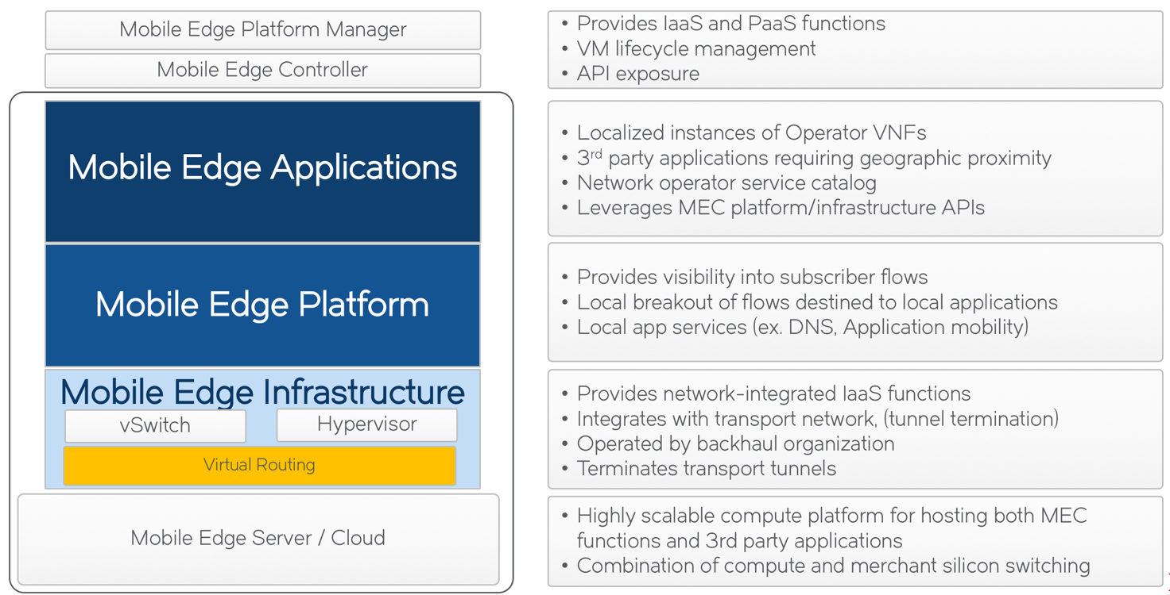

In order to realize a complete solution, multiple vendors are collaborating to determine the integration points, APIs, data models, and workflows necessary to ensure seamless integration and communication between the various layers depicted on the diagram. The vendors collaborating in this solution consist of:

Component | Vendor
Mobile Edge Server/Cloud | Packetarium XLc Carrier Grade Blade Server
Mobile Edge Infrastructure and user data plane | Virtual Services Platform
Mobile Edge Platform and Mobile Edge Applications | Open-RAN | SmartAir
Mobile Edge Platform Manager / Mobile Edge Controller | Cloud Orchestration | Workflow Composer

Representative enterprise and Internet applications will be used to demonstrate the capabilities of the MEC PoC for delivering visibility and improved experience. Although these applications are yet-to-be-defined, the nature of the applications are largely irrelevant for the completion of the PoC, and are only demonstration tools.

Architecturally, the solution above maps to the ETSI MEC ISG architecture defined in Mobile Edge Computing (MEC); Framework and Reference Architecture (ETSI GS MEC 003 V1.1.1), as follows.
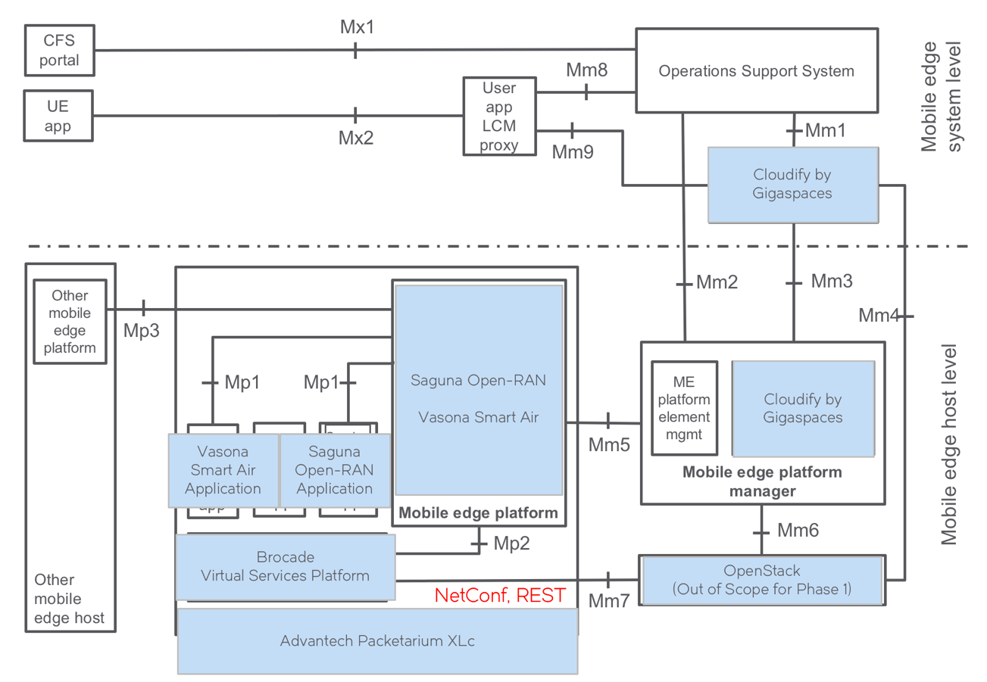

With regard to interfaces and APIS, the proposed PoC will leverage the following:
- An internal API, leveraging either GRPC or a Message Bus REQ/REP pattern, will be developed between the Mobile Edge Platforms (Saguna, Vasona), and the Mobile Edge Infrastructure (Brocade VSP). This is similar to the Mp2 interface.
- An API to expose the service registry from the platform will list all available services hosted/running on the platform and is a subset of the functionality expected on Mm5.
- The integration of OpenStack VIM is out-of-scope for Phase 1 of the PoC in order to simplify the layered architecture within the management framework of the solution.
  - For PoC Phase 1, The Mobile Edge Platform Manager (Cloudify Cloud Orchestrator) will speak directly to the Virtualization Infrastructure (Brocade Virtual Services Platform) via NetConf through a set of published YANG models.
  - The Mobile Edge Platform Manager, in this instance, will subsume the functionality of the VIM, and the Mm3, Mm4, Mm6 interfaces will be internal to Cloudify Cloud Orchestration.

2.3 Additional information

