Title*: | Distributed MEC based AR remote maintenance for logistics transportation
from Source*: | China Telecom
Contact: | zengq@chinatelecom.cn,zhuhongm@chinatelecom.cn
input for Committee*: | MEC
Contribution For*: | Decision | X
 | Discussion
 | Information
Submission date*: | 2023-10-31
Meeting & Allocation: | MEC#304-Tech
Relevant WI(s), or deliverable(s):

Decision/action requested: Please approve

ABSTRACT: This PoC proposal describes the 5G distributed MEC solution to support remote maintenance of AR in logistics transportation. This solution can effectively improve the efficiency of logistics transportation and reduce the maintenance cost.

PoC Proposal

1 PoC Project Details

1.1 PoC Project
PoC Number (assigned by ETSI):
PoC Project Name: Distributed MEC based AR remote maintenance for logistics transportation
PoC Project Host: China Telecom
Short Description: This PoC proposal describes the 5G distributed MEC solution to support remote maintenance of AR in logistics transportation. This solution can effectively improve the efficiency of logistics transportation and reduce the maintenance cost.

1.2 PoC Team Members
 | Organisation name | ISG MEC participant  (yes/no) | Contact (Email) | PoC Point of Contact  (*) | Role (**) | PoC Components
1 | China Telecom | yes | zengq@chinatelecom.cn  zhuhongm@chinatelecom.cn |  | network operator
2 | China Telecom Intelligent NETWORK Technology Co., LTD |  | hewt06@chinatelecom.cn |  | application provider
3 | Huawei | yes | yangfan@huawei.com |  | infrastructure provider
…
(*) Identify the PoC Point of Contact with an X.
(**) The Role will be network operator/service provider, infrastructure provider, application provider or other.

All the PoC Team members listed above declare that the information in this proposal is conformant to their plans at this date and commit to inform ETSI timely in case of changes in the PoC Team, scope or timeline.

1.3 PoC Project Scope

1.3.1 PoC Topics
PoC Topics identified in this clause need to be taken for the PoC Topic List identified by ISG MEC and publicly available in the MEC WIKI. PoC Teams addressing these topics commit to submit the expected contributions in a timely manner.
PoC Topic Code | PoC Topic Description | Related WG/WI | Expected Contribution | Target Date
WT01 | Demonstration of MEC Service Scenarios | MEC-002 Service Scenarios ；MEC 014 UE Identity ，MEC047 Distributed Edge ; | Technical Report describing the Service Scenario and providing the lessons learnt and technical information requested by WT#01 | Q2 2024

1.3.2 Other topics in scope
List here any additional topic for which the PoC plans to provide input/feedback to the ISG MEC.
PoC Topic Code | PoC Topic Description | Related WG/WI | Expected Contribution | Target Date
A
B
<…>

1.4 PoC Project Milestones
PoC Milestone | Milestone description | Target Date | Additional Info
P.S | PoC Project Start | Q2 2023
P.D1 | PoC Expected Contribution 1 –From August 29 to 31, 2023, the third plenary meeting of the Industrial Internet Technology Working Committee has been held in Kunming, and the working group meetings of TC13 has been held at the same time. China Telecom combined with China Telecom Intelligent Network Technology Co., LTD and other related companies demonstrated the MEC-based AR remote maintenance method. The actual use effect of remote maintenance verifies that the proposed method is conducive to improving the efficiency of logistics transportation. | Q3 2023 | TC13WG2SWG1:5G+ Industrial Internet 4th Working Group meeting
P.D2 | PoC Expected Contribution 2 –WG2 44th, WG1 SWG1 25th, WG1 SWG2 27th, WG1 SWG5 25th, WG1 SWG6 12th, WG1 SWG6&WG1 has been held in Beijing from September 26 to 27, 2023 The 1st joint meeting of SWG5, the 12th meeting of -2-WG1 SWG7, and the 12th meeting of CAA/CCSA JWG. The AR remote maintenance method was unanimously approved by all participants. | Q3 2023 | TC11WG1SWG6&TC11WG1SWG5 1st joint meeting
P.C1 | PoC Expected Contribution 3 –The 37th Plenary Session of TC7 has been held in Ningbo from October 17 to 20, 2023. China Telecom gave a speech on AR remote maintenance and gradually promoted MEC projects across the country, especially to help logistics companies build smart logistics. Companies such as China Telecom have gained industry-wide recognition. | Q4 2023 | 9th joint meeting of TC7WG1&TC7WG2&TC7WG3
P.R | PoC Report | Q1 2024 | Overall architecture and description of scheme
P.E | PoC Project End | Q2 2024

NOTE: Milestones need to be entered in chronological order.

1.5 Additional Details
For example, URL, planned publications, conferences, etc.

2 PoC Technical Details

2.1 PoC Overview
The Distributed MEC based AR remote maintenance application solution for logistics transportation allows operators to help logistics companies build smart logistics for AR remote maintenance. At present, when the truck breaks down on the way of logistics transportation, the driver needs to park the truck at the side of the road to wait for the maintenance personnel, or wait for the rescue vehicle to tow the truck away. This not only increases the maintenance time of the truck, but also increases the maintenance cost of the truck, because it takes time for the maintenance personnel to come to the truck parking point and incurs additional transportation costs. This greatly damages the efficiency of logistics.
A logistics company is the end-to-end project of cloud network integration, focusing on the combination of edge MEC and industrial Internet application scenarios, creating intelligent warehousing and factory logistics system integration solutions, and realizing 5G AR remote maintenance. The following is a detailed description of this solution. The 5G core network is centrally deployed, and the edge UPFs and MEC platforms serving for this company are deployed distributedly with a large number to meet the emergency maintenance that may occur in any location. In this PoC proposal, we focuses on building a vertical solution to solve the current maintenance problem of logistics transportation. This PoC mainly considers the following value driver:
- 5G + AR remote maintenance: AR glasses are equivalent to fixed cameras, which are more mobile and flexible, with strong mobility and clearer images. When the truck transporting goods breaks down on the road, the staff can enable AR remote maintenance service and wear AR glasses to report the fault status to the MEC platform in real time. The platform compares the pre-configured model based on the received information, generates results, and sends 3D maintenance instructions to the remote This can effectively shorten the vehicle maintenance time and reduce maintenance costs.
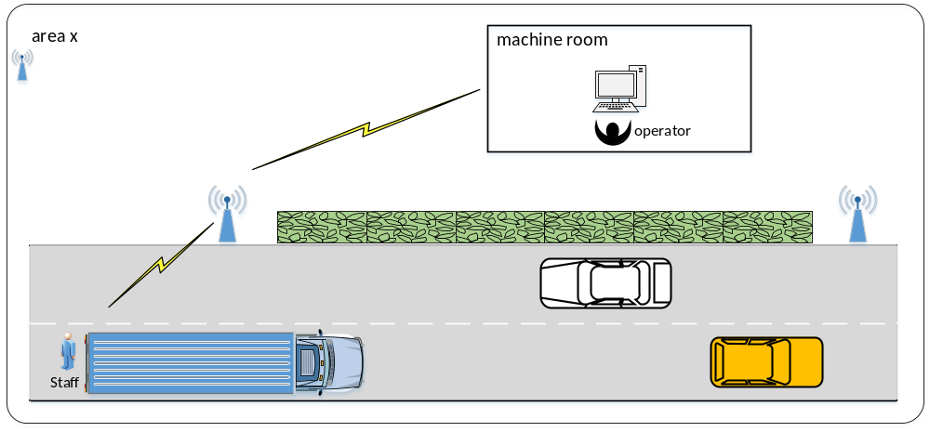
Figure 1: 5G + AR remote maintenance

2.2 PoC Architecture
MEC solution: As said above, MEC and UPF is deployed in the edge machine room of China Telecom. And China Telecom has assigned a dedicated data network with a special DNN to this logistics company.That’s a batch of customized DNN UIMs. When the AR with this kinds of UIMs connects the 5G base stations, they have dedicated route so as to guarantee its quality and limited the use, dedicated to the remote maintenance.
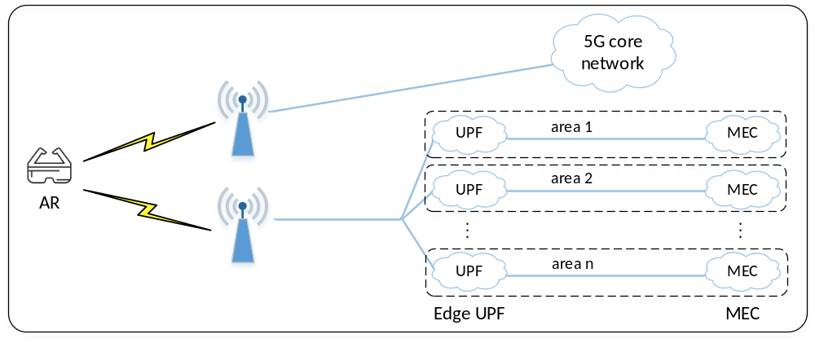
Figure 2: Architecture diagram of Distributed MEC based AR remote maintenance for logistics transportation
Pre-conditions:
- Maintenance server is hosted on the distributed MEC platform;
- China Telecom assigned a special DNN for this logistics transportation, that’s each AR glasses together with the truck is equipped with this dedicated DNN 5G UIM.
- When the AR glasses initiates a PDU session, which will be routed to a nearest edge UPF.
Figure 2 shows the architecture diagram of MEC based AR remote maintenance for logistics transportation, the detailed process is as follows:
- The staff/driver sends the information of the truck failure to the base station in real time through AR glasses.
- The base station sends the received information to the nearest edge UPF/MEC platform.
- Maintenance sever compared the data after computed with the pre-configured model, give back the instructions to the remote staff/driver to realize the remote maintenance.

2.3 Additional information

