Network resource allocation for Gaming using MEC BandWidth Management service and TeraFlowSDN

1 PoC Project Details

1.1 PoC Project
PoC Number (assigned by ETSI):
PoC Project Name: Network resource allocation for Gaming using MEC BandWidth Management service and TeraFlowSDN.
PoC Project Host: CTTC
Short Description:
MEC BandWidth Management (BWM) service and TeraFlowSDN can be used to provide dedicated resources for network resource allocation for Gaming. BWM allows applications to allocate specific amounts of bandwidth to gaming applications, while TeraFlowSDN provides a way to manage and control traffic flows. This can help to ensure that gaming traffic has priority over other traffic, which can improve the gaming experience for users. The tests of this compute-network interface can also be interesting for upcoming 6G networks.

1.2 PoC Team Members
 | Organisation name | ISG MEC participant  (yes/no) | Contact (Email) | PoC Point of Contact  (*) | Role (**) | PoC Components
1 | CTTC | YES | ricard.vilalta@cttc.es | X | Infrastructure provider | TeraFlowSDN  Edge routers and servers
2 | xFlow | YES | muhammad.hamza@xflowresearch.com | X | Aplication provider | App
3 | Telefónica | YES | diego.r.lopez@telefonica.com  joseantonio.ordonezlucena@telefonica.com |  | Network Operator | -
(*) Identify the PoC Point of Contact with an X.
(**) The Role will be network operator/service provider, infrastructure provider, application provider or other.

All the PoC Team members listed above declare that the information in this proposal is conformant to their plans at this date and commit to inform ETSI timely in case of changes in the PoC Team, scope or timeline.

1.3 PoC Project Scope

1.3.1 PoC Topics
PoC Topics identified in this clause need to be taken for the PoC Topic List identified by ISG MEC and publicly available in the MEC WIKI. PoC Teams addressing these topics commit to submit the expected contributions in a timely manner.
PoC Topic Code | PoC Topic Description | Related WG/WI | Expected Contribution | Target Date
Topic 4 | MEC-enabled Vertical Segments applications
Topic 3 | MEC Architecture

1.4 PoC Project Milestones
PoC Milestone | Milestone description | Target Date | Additional Info
P.S | PoC Project Start | 01/09/23
P.C1 | PoC Expected Contribution 1 | 01/11/23
 | Submission for OFC24 demo | 15/11/23
P.D1 | First Preliminary PoC Demo | 04/12/24 | MEC Plenary #36
P.D2 | PoC Demo 2 | 15/03/24 | San Diego, F2F
P.D3 | PoC Demo 3 | 18/03/24 | MEC Plenary #37
P.D4 | PoC Demo 4 | 01/04/24 | Webinar
P.R | PoC Report | TBD
P.E | PoC Project End | TBD

1.5 Additional Details
Demo paper OFC 24: https://www.ofcconference.org/en-us/home/submit-papers/topic-categories/
This work is partly supported by Hexa-X-II project, receiving funding from the SNS JU under the European Union’s Horizon Europe research and innovation programme (GA no. 101095759).

2 PoC Technical Details

2.1 PoC Overview
MEC BandWidth Management (BWM) service and TeraFlowSDN can be used to provide dedicated resources for network resource allocation for Gaming. BWM allows applications to allocate specific amounts of bandwidth to gaming applications, while TeraFlowSDN provides a way to manage and control traffic flows. This can help to ensure that gaming traffic has priority over other traffic, which can improve the gaming experience for users.
Here are some of the benefits of using MEC BBM and TeraFlowSDN for gaming networking: Improved gaming performance, reduced congestion, and Increased scalability. By ensuring that gaming traffic has priority, BWM and TeraFlowSDN can help to reduce latency and improve the overall gaming experience. By allocating specific amounts of bandwidth to gaming applications, BWM and TeraFlowSDN can help to reduce congestion on the network, which can improve the gaming experience for all users. Finally, BBM and TeraFlowSDN can be easily scaled to accommodate more users and traffic, which is important for gaming applications that are expected to grow in popularity.
Overall, MEC BWM and TeraFlowSDN can be a valuable tool for operators who want to provide a dedicated gaming experience for their users.

2.2 PoC Architecture
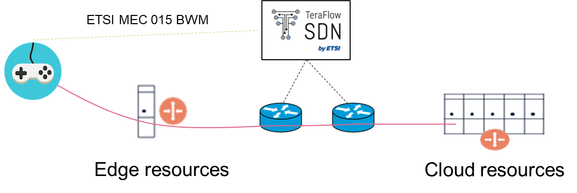
Network resource allocation for gaming using MEC BandWidth Management (BWM) service and TeraFlowSDN (TFS) can be done in the following steps:
- Identify the gaming applications that need dedicated resources. This can be done by analyzing the traffic patterns of gaming applications and identifying the ones that are most demanding in terms of bandwidth.
- Set up TeraFlowSDN including network equipment (e.g., CSGW). This involves installing the software and configuring the policies that will be used to allocate bandwidth to gaming applications.
- Allocate bandwidth to gaming applications. xFlow application will send to TeraFlowSDN bandwidth allocation request. The amount of bandwidth that is allocated to each application will depend on the traffic patterns and the performance requirements of the application.
- TFS will monitor the network traffic. This is important to ensure that the bandwidth that is allocated to gaming applications is not being used by other applications.
Here are some additional considerations for network resource allocation for gaming using MEC BWM and TeraFlowSDN:
- The amount of bandwidth that is allocated to gaming applications will depend on the type of game and the number of users. For example, a multiplayer game that requires real-time communication will need more bandwidth than a single-player game.
- The location of the gaming applications will also need to be considered. If the gaming applications are hosted in the cloud, then the bandwidth that is allocated to them will need to be sufficient to support the round-trip latency between the user and the cloud.
- The network traffic flows will need to be monitored to ensure that the bandwidth that is allocated to gaming applications is not being used by other applications. If the bandwidth is being used by other applications, then the policies that were set up in step 2 will need to be adjusted.
Overall, MEC BWM and TeraFlowSDN can be a valuable tool for operators who want to provide a dedicated gaming experience for their users. By carefully allocating bandwidth to gaming applications, operators can improve the gaming experience for users and reduce congestion on the network.

2.3 Additional information
…

