Title*: | PoC Proposal: MEC platform to enable OTT business
from Source*: | China Unicom, ZTE, Intel
Contact: | Huazhang Lv : lvhz7@chinaunicom.cn  Qiang Huang : huang.qiang1@zte.com.cn  Yifan Yu : yifan.yu@intel.com
input for Committee*: | MEC
Contribution For*: | Decision | X
 | Discussion
 | Information
Submission date*: | 2018-03-04
Meeting & Allocation:
Relevant WI(s), or deliverable(s):

Decision/action requested: Please approve

ABSTRACT: This MEC PoC proposal is about enabling MEC Services in OTT business and CDN use cases based on the current MEC reference architecture.

PoC Proposal

1 PoC Project Details

1.1 PoC Project
PoC Number (assigned by ETSI):

PoC Project Name: MEC platform to enable OTT business

PoC Project Host: China Unicom

Short Description: This ETSI MEC PoC proposal is about enabling OTT business on MEC platform: distributing OTT’s CDN to the MEC platform in the network of China Unicom. The combination of CDN and MEC can reduce the RTT and increase the HTTP download rate. The MEC platform is crucial for China Unicom to cooperate with OTT partners for the advanced OTT business. China Unicom is considering to deploy and enable more applications and business such as AR/VR, security monitoring based on AI and location service on the MEC platform.

China Unicom MEC platform is an MEC standard based open source platform which allows 3rd party applications and OTT business to be deployed on the edge of the networks. This standard based approach is helpful for the rapid deployment and commercializing more OTT applications in the future.

This PoC is developed on the 4G networks. But it can also gain valuable experience and prepare for the future transform of edge data centre of China Unicom in the 5G.

1.2 PoC Team Members
 | Organisation name | ISG MEC participant  (yes/no) | Contact (Email) | PoC Point of Contact  (*) | Role (**) | PoC Components
1 | China  Unicom | Yes | Huazhang Lv  lvhz7@chinaunicom.cn  Dan Chen  Chendan49@chinaunicom.cn | X | Operator | (i)Wireless network and optical fibre network  (ii) Guidance and feedback
2 | ZTE | Yes | Qiang Huang  huang.qiang1@zte.com.cn |  | Infrastructure Provider | MEC host and management
3 | Intel | Yes | Yifan Yu  yifan.yu@intel.com  Hongli Zeng  hongli.zeng@intel.com |  | Infrastructure Provider | X86 servers and accelerator cards
4 | Tencent | No |  |  | Application Provider | Tencent video app (non- customised version)
5 | Wo video | No |  |  | Application Provider | Wo video app (non- customised version)
6 | UnitedStack | No |  |  | Infrastructure Provider | Virtual OS and virtualization infrastructure management
(*) Identify the PoC Point of Contact with an X.
(**) The Role will be network operator/service provider, infrastructure provider, application provider or other.

All the PoC Team members listed above declare that the information in this proposal is conformant to their plans at this date and commit to inform ETSI timely in case of changes in the PoC Team, scope or timeline.

1.3 PoC Project Scope

1.3.1 PoC Topics
PoC Topics identified in this clause need to be taken from the PoC Topic List identified by ISG MEC and publicly available in the MEC WIKI. PoC Teams addressing these topics commit to submit the expected contributions in a timely manner.

PoC Topic Code | PoC Topic Description | Related WG/WI | Expected Contribution | Target Date
PT01 | Demonstration of MEC Service Scenarios | MEC-004 Service Scenarios  MEC-009  General Principles for Mobile Edge Service APIs  MEC-012 Radio Network Information APIs. | PC1 - Technical report and demonstration with the following lessons learned and technical information:  - MEC Services (Tencent video instance):  - Traffic Offload Function  - CDN scheme based on NAPT (Network Address Port Translation)  - DNS rules used for OTT business  - Unified APIs for enabling OTT business in MEC platform  - RNIS based code rate adaptation for video OTT | Mobile World  Congress  June 2018
PT02 | MEC Architecture | MEC-003 Framework and Reference Architecture  MEC-006 - Metrics Best Practice and Guidelines  MEC-010-1 System, Host, and Platform Management  MEC-010-2 Application Lifecycle, Rules, and Requirements Management  MEC-011 Mobile Edge Platform Application Enablement  MEC-013 Location API | PC1 - Technical report and demonstration with the following lessons learned and technical information:  - Demonstrate MEC reference architecture based on x86, OpenStack and OpenSource MANO;  - Demonstration of MEC platform management and Cloud Orchestration supporting CDN scheme and DNS rules;  - Demonstration of NAPT for CDN  - Location Service based support for business analyse OTT. | Q4 2018

1.3.2 Other topics in scope
List here any additional topic for which the PoC plans to provide input/feedback to the ISG MEC.
PoC Topic Code | PoC Topic Description | Related WG/WI | Expected Contribution | Target Date
A
B
<…>

1.4 PoC Project Milestones
PoC Milestone | Milestone description | Target Date | Additional Info
P.S | PoC Project Start | Jan 10, 2018 | Mobile World Congress 2018, Barcelona
P.D1 | PoC Demo 1 – Tencent CDN | Q2 2018 | Mobile World Congress 2018, Shanghai
P.D2 | Poc Demo 2 – Wo Video CDN and code rate adaptation experiment. | Q3 2018 | MEC Congress 2018, Berlin
P.D3 | PoC Demo 3 – Location business and security monitoring | Q4 2018
P.R | PoC Report | Feb 2019 | Publish a final report for the PoC
P.E | PoC Project End | Q1 2019

1.5 Additional Details
For example, URL, planned publications, conferences, etc.

2 PoC Technical Details

2.1 PoC Overview
Multi-Access Edge Computing (MEC) provides a new ecosystem and value chain, and the opportunity for new players to collaborate. It creates new business models to benefit every player. Now China Unicom grips the reform opportunity with OTT service providers such as Alibaba, Tencent, Baidu and JDcom. OTT business is growing very fast and now becomes the important economic growth points. MEC provides a good opportunity for network operator to work with OTT service providers and realize the digital transformation of China Unicom. This PoC will demonstrate the MEC capabilities in support of a non-customized OTT application use case such as distributed CDN.

In this PoC proposal we will focus on building a vertical solution that addresses today’s requirements of OTT business and demonstrates the feasibility of building a service model for OTT. This PoC mainly considers the following value drivers:

- The architecture of non-customized OTT business: CDN, deployment on the edge cloud of China Unicom: This is the first time to deploy the non-customized OTT CDN business on the edge cloud of China Unicom. Unlike the previous cases that the OTT should customize its CDN for the deployment in the MEC platform, this PoC enables the seamless integration between the edge cloud in the MEC platform and Tencent’ central cloud. China Unicom provides the resource of edge data center and network connection. Intel and ZTE provides infrastructure for communication and computation, respectively. We use the MEC based edge cloud to implement the distributed CDN to provide Tencent and Wo video’s streaming service to the users in Tianjin University Town. The users are able to view the videos which are fetched from the CDN surrogate servers in their proximity instead of those in the central site that is far away from them.

- Propose the requirements of OTT Business: OTT has become one of the most active businesses. In China, the fastest growing OTT service providers, Baidu, Alibaba, and Tencent (BAT), own the most advanced development concept and business model. China Unicom is a traditional telecom operator, and takes the leadership in cooperating with BAT. Edge cloud is valuable resource of China Unicom to cooperate with BAT and other OTT service providers. We propose generic OTT requirements for the MEC based edge cloud platform. In this PoC proposal, it demonstrates the non-customized Tencent CDN running on the MEC based edge cloud. In the future, China Unicom will provide such open platform to 3rd party content providers and other OTT service providers.

- The particularity of edge data center setting and resource allocation: In the PoC demo at Tianjin University Town, the virtual OS and platform management provider UnitedStack make an alternative scheme comparing to the standard cloud configuration. As China Unicom will commercialize 5G networks including reconstruction of edge data center in 2020, it is necessary to investigate and provide the recommendation of edge cloud configuration suitable for edge data center based on experience of the PoC.

We will demonstrate the performance improvement of OTT business via using MEC services through the standardized Mp1 interface, such as traffic rules configuration, DNS handling configuration, RNIS and location service in this PoC project later. The performance gain will be present given diverse OTT applications such as Wo video, location function and VR teaching, in addition to the initial OTT service of Tencent video CDN.

2.2 PoC Architecture
This PoC will be built around the premise of China Unicom current network connection.

The APPs deployed in the MEC platform include the CDN surrogate server for Tencent video streaming, the CDN surrogate server for Wo video streaming, location function and VR teaching and so on. The CDN surrogate server for Tencent video streaming is deployed in a VM acting as the mobile edge application. There is no any customization dedicated for the MEC platform in Tencent CDN including the surrogate servers in the edge cloud and the server scheduler (i.e. GSLB: Global Server Load Balancing) in the central cloud.

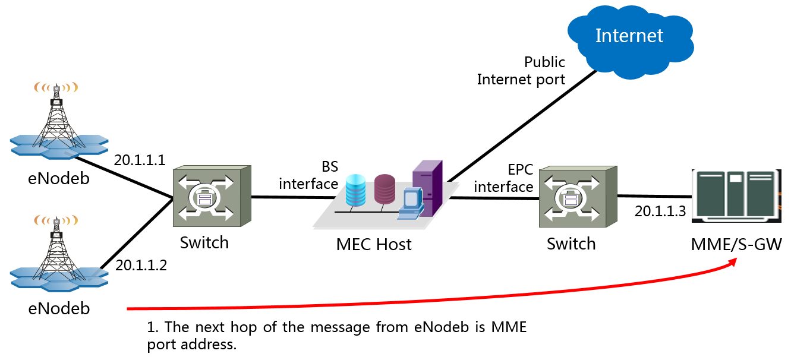
Figure 1- PoC built over L2 Networks

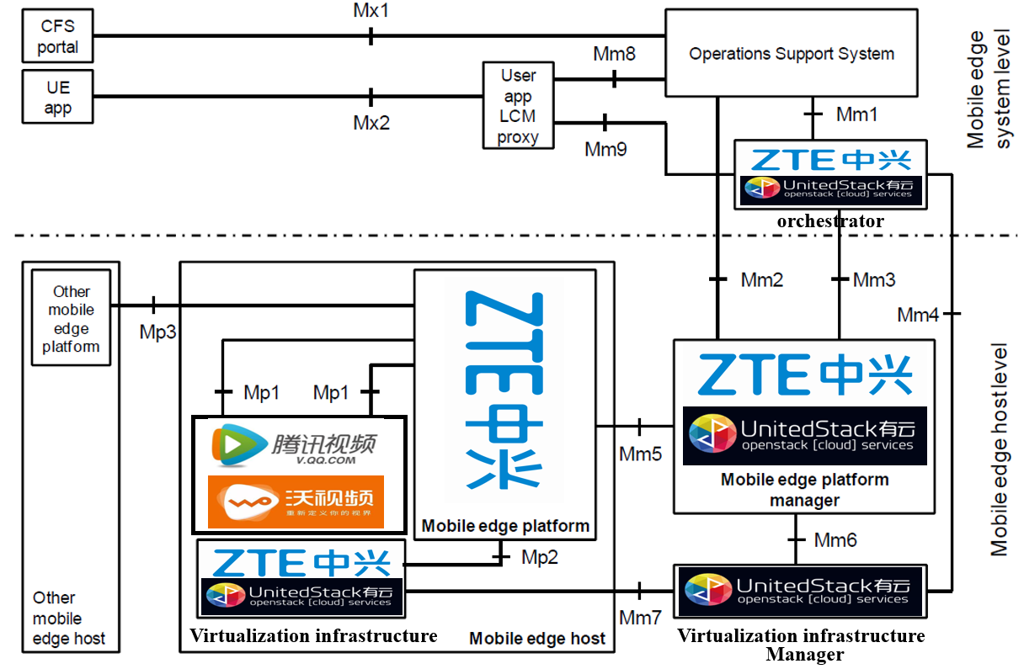
Figure 2- Mapping of PoC of China Unicom with MEC Reference Architecture

In order to reduce the impact on the network currently operated by China Unicom, the PoC is deployed in the carrier site within Tianjin University Town. As in Figure 1, it is built on the layer 2 networks which do not need to modify the configuration on eNodeB and EPC and enable the direct connection between the base station /PTN network and the switching.

According to the PoC deployment illustrated in Figure 1, an MEC host is installed between the base station and the mobile core network and acts as a layer 2 switch in the PTN network. The MEC host is transparent to the existing network and imposes no any transmission configuration.

Figure 2 shows the architectural mapping of components in PoC of China Unicom to the MEC reference architecture specified by ETSI GS MEC-003: Network resource is provided by China Unicom and the MEC hardware infrastructure is provided by Intel and ZTE.

2.3 Additional information

2.3.1 Requirements of OTT Business
In this section, the requirements for the deployment of OTT business in the MEC platform are present. According to China Unicom’s planning on edge cloud building, the MEC platform should be the open and general architecture wherein the OTT business and other 3rd party applications can be readily deployed without additional customization. Especially, the service deployed in the edge cloud can be seamlessly integrated with other business in the central cloud.

OTT prefers to the service delivery under its own control rather than that by the external party, including vendors and operators.

Since OTT intensively places emphasis on the user experience, it prefers to deliver the service under its own control in terms of the process logic and business framework. To take Tencent video streaming as the example, it has built the matured and large-scale streaming platform serving tens of millions of users. Tencent therefore relies on its own scheduling system to select the steaming server to process the user’s request. If it hands over the server scheduling to the external party, there will be the architectural modification in its platform which includes the front-end component in the clients that may be installed in hosts of smart phones and the back-end servers that are deployed in multiple cloud sites. Thus, Tencent has to be confronted with the increased cost due to the segmented product development. There is the similar observation in other OTTs and 3rd party service providers. Figure 3 summarizes the OTT business requirements.

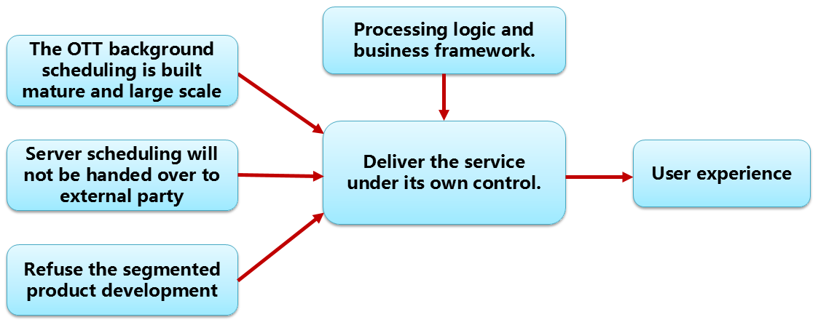
Figure 3- OTT business requirements.

2.3.2 Test Results of Tencent CDN in MEC based Edge-Cloud
The preliminary test results of PoC are present in Table 1. The average RTT is reduced by approximately 50% and the average HTTP download rate is increased by 43%. In the future, more applications such as Wo-Video, AV/VR, location based services and security monitoring etc are to be deployed and tested in the PoC. It is believed that the additional advantages of applications based on MEC platform will gradually become more prominent.

Table 1- Test Results of CDN in Tianjin Baodi PoC
 | Tencent video |  | Performance Gain
 | CDN in Central Cloud | CDN in MEC
Average RTT (ms) | 48.75 | 23.21 | RTT reduced by 50%
Average HTTP download rate（Mbps） | 69.2 | 98.9 | HTTP download rate increased by 43%

