Title*: | POC Proposal: FLIPS: Flexible IP-Based Services
from Source*: | InterDigital
Contact: | Alex Reznik (InterDigital)
input for Committee*: | MEC IEG
Contribution For*: | Decision | X
 | Discussion
 | Information
Submission date*: | 2016-03-22
Meeting & Allocation: | MECIEG#15; MECIEG#16
Relevant WI(s), or deliverable(s):

Decision/action requested: Please approve

ABSTRACT: This is an MEC PoC submission about Flexible IP-Based Services in the Mobile Edge. r2 addresses comments and actions raised during the review in MECIEG#15. r3 addresses comments made after initial acceptance of the PoC.

PoC Proposal

1 PoC Project Details

1.1 PoC Project
PoC Number (assigned by ETSI):
PoC Project Name: FLIPS – Flexible IP-based Services
PoC Project Host: InterDigital
Short Description: An operator-based MEC Application is designed to transparently accelerate delivery of IP-based content and streaming media. This Application additionally allows exposure of in-network surrogate server to allow operators to offer Surrogate-as-a-Service for web-based media delivery.

1.2 PoC Team Members
 | Organisation name | ISG MEC participant  (yes/no) | Contact (Email) | PoC Point of Contact  (*) | Role (**) | PoC Components
1 | InterDigital | Yes | Alex Reznik  alex.reznik@interdigital.com  Dirk Trossen  dirk.trossen@interdigital.com | X | Infrastructure Provider | Flexible routing and surrogate platform
2 | Bristol is Open | No | Dimitra Simeonidou dimitra.Simeonidou@bristol.ac.uk |  | Service Provider | Urban open radio access network with SDN optical backhaul
3 | Intracom | No | Spiros Spirou  spis@intracom-telecom.com |  | Infrastructure Provider | HLS video platform
4 | CVTC | No | Stuart Porter stuart.porter@truetube.co.uk |  | Application provider | Video streaming application
5 | Essex University | No | Martin Reed  mjreed@essex.ac.uk |  | Other | Integration of the system on the SDN platform
(*) Identify the PoC Point of Contact with an X.
(**) The Role will be network operator/service provider, infrastructure provider, application provider or other.

All the PoC Team members listed above declare that the information in this proposal is conformant to their plans at this date and commit to inform ETSI timely in case of changes in the PoC Team, scope or timeline.

1.3 PoC Project Scope

1.3.1 PoC Topics
PoC Topics identified in this clause need to be taken from the PoC Topic List identified by ISG MEC and publicly available in the MEC WIKI. PoC Teams addressing these topics commit to submit the expected contributions in a timely manner.
PoC Topic Code | PoC Topic Description | Related WG/WI | Expected Contribution | Target Date
PT#01 | Demonstration of MEC Service Scenario (new scenario) | MEC-IEG004 | Technical Report describing the Service Scenario and providing the lessons learnt and technical information requested by PT#01 | Q4 2016
PT#02 | MEC Metrics | MEC-IEG006 | Technical report describing the results of the evaluation of the proposed PoC against an estimate of the best case performance of a reference system. The focus is on Latency, Network Throughput and MEC Server Load metrics | Q4 2016

1.3.2 Other topics in scope
List here any additional topic for which the PoC plans to provide input/feedback to the ISG MEC.
PoC Topic Code | PoC Topic Description | Related WG/WI | Expected Contribution | Target Date
n/a

1.4 PoC Project Milestones
PoC Milestone | Milestone description | Target Date | Additional Info
P.S | PoC Project Start | Feb. 7, 2016
P.D1 | PoC Demo at MWC | Feb. 2016 | Demonstration of the PoC system only with contrasting network throughput to best-case IP reference setup.
P.D2 | PoC Live Demo at Bristol using Bristol Is Open network | May 2016 | Demo and testing on a live system against the estimated best-case performance of a reference system. Measured experiments are conducted using pre-defined user groups, while general demo is available to public to use.
P.D3 | Webinar | Q3-2016
P.D4 | PoC Demo at MEC World Congress | Sep. 2016 | This demo includes the PoC system being contrasted against the estimated best-case performance of the reference system, i.e., improvement in PT#02 metrics (latency and network throughput) is shown.
P.R | PoC Report | Q4-2016 | Includes Technical sections detailing the Service Scenario. The use of SDN to deploy an ICN-based system for Video delivery shall be detailed for PT#01. The results of evaluation against Latency and Network Throughput Metrics shall be detailed for PT#02.
P.E | PoC Project End | Q4-2016

NOTE: Milestones need to be entered in chronological order.

1.5 Additional Details

2 PoC Technical Details

2.1 PoC Overview
It is becoming openly acknowledged that the future of the 5G networks involves extensive cooperation between Carriers and OTT players in order to meet the strict 5G requirements, particularly regarding service-level latency and aggregate throughput. Such 5G requirements are forcing a radical re-thinking of the Mobile Network architecture moving toward 5G. It is generally agreed that a more flexible network architecture needs to emerge and Mobile Edge Computing is likely to be a vital component of this new architecture. Another key component of the emerging network is the proliferation of SDN and the emergence of a programmable network model that allows rapid provision and adaptation of data forwarding paths to optimize network performance.

The goal of this PoC is to demonstrate how operators can use their edge networks to accelerate content and streaming media delivery to their customers who are also clients of OTT services. The PoC assumes a deployment where a single MEC server “covers” several radio network components and where the MEC-enabled network has the capability to configure a forwarding plane interconnecting these components and connecting them to the core network and the external cloud. The usage of Information-centric Networking (ICN) based forwarding rules enables the implementation of native multicast of streaming media.

Furthermore, a MEC application within at the MEC Server is used to configure the insertion of alternative playout locations in order to provide an optimized delivery of OTT provider’s streaming media. The PoC demonstrates this as a Surrogate-as-a-Service concept that operators can offer to OTT providers through the use of surrogate servers within the network, extending from the concept of caching static objects towards migrating computation as well as content within the network. The MEC policy based selection of surrogate instances is controlled by SDN/ICN core functions, which utilize ICN knowledge about what information is requested where and by how many users.

The PoC will demonstrate both the viability of using Mobile Edge Computing to implement such streaming media acceleration as well as the performance advantages achieved over traditional approaches.

2.2 PoC Architecture
The PoC architecture is shown in Figure 1. This consists of several radio network access points (e.g., the access points of the Bristol-Is-Open network or access points provided at a booth-based PoC setup) to which actual subscribers are attached. The NAPs are able to group HTTP responses (i.e., the video chunks) into few multicast responses which, in turn, are delivered via an SDN forwarding fabric. The operator’s network includes an SDN based forwarding plane and a Border GW for interconnection with IP-based extranets. An additional 200 users can be emulated via a Mininet-based cloud setup to provide additional network load. The MEC application consists of a standard HLS (HTTP-level streaming) video application, delivering HTTP unicast videos to the clients. Finally, the architecture includes a surrogate server, representing an authoratative copy of the original video server. Said surrogate server is activated by the MEC application based on dynamic load conditions in the network and integrated into the routing fabric with a sub-1s delay. The policies for integration and activation of the surrogate are set by the MEC service provider.

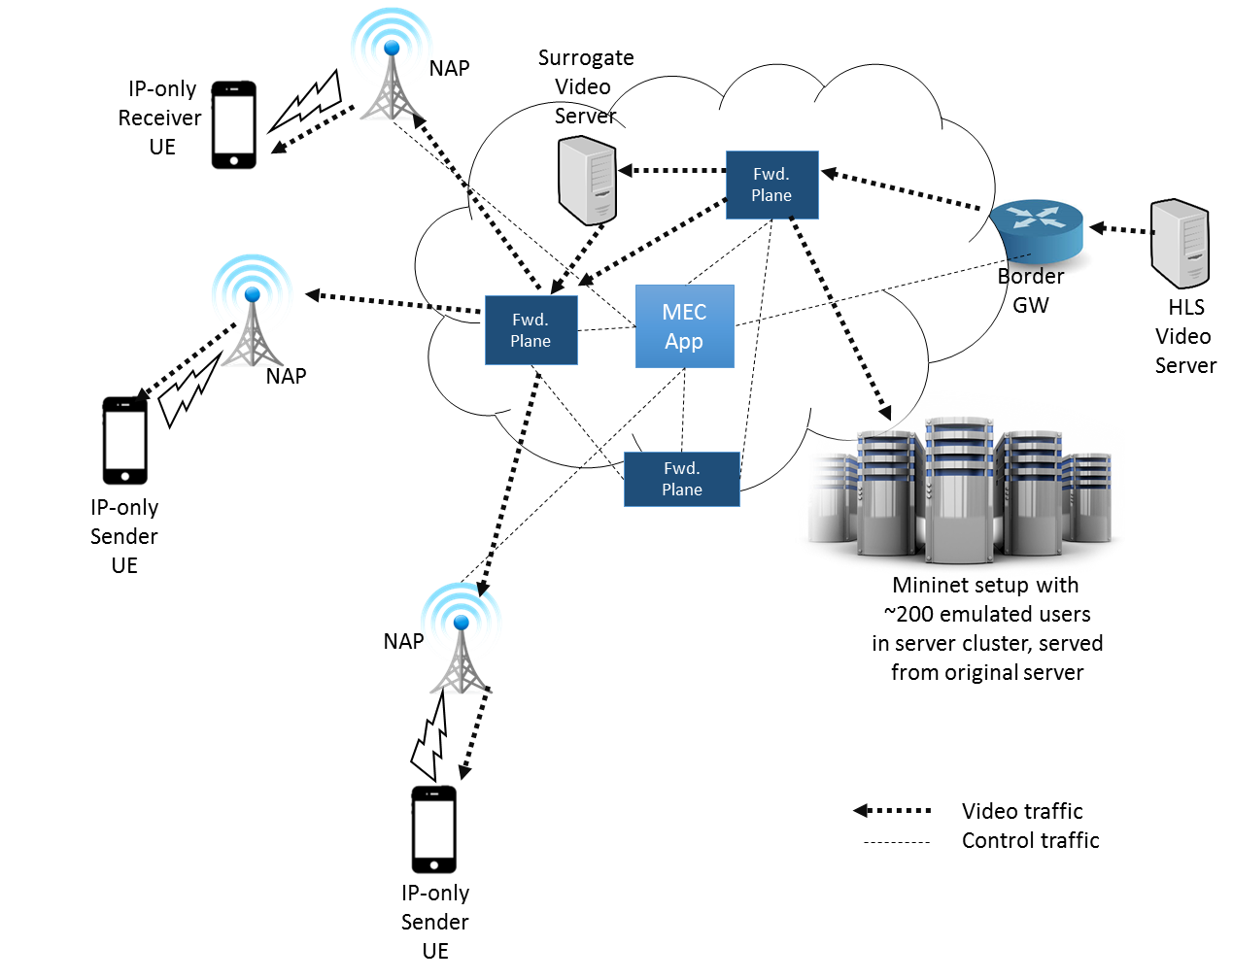
Figure 1 POC Architecture

Figure 2 shows a reference IP-based routing in such scenario. Each request for an HLS video streams leads to an individual HTTP unicast responses for each video chunk which is resolved using a traditional DNS approach and routed using traditional IP routing. In our PoC, we will showcase the performance metrics against the estimated best-case performance (e.g., neglecting possible losses) of such a reference system.

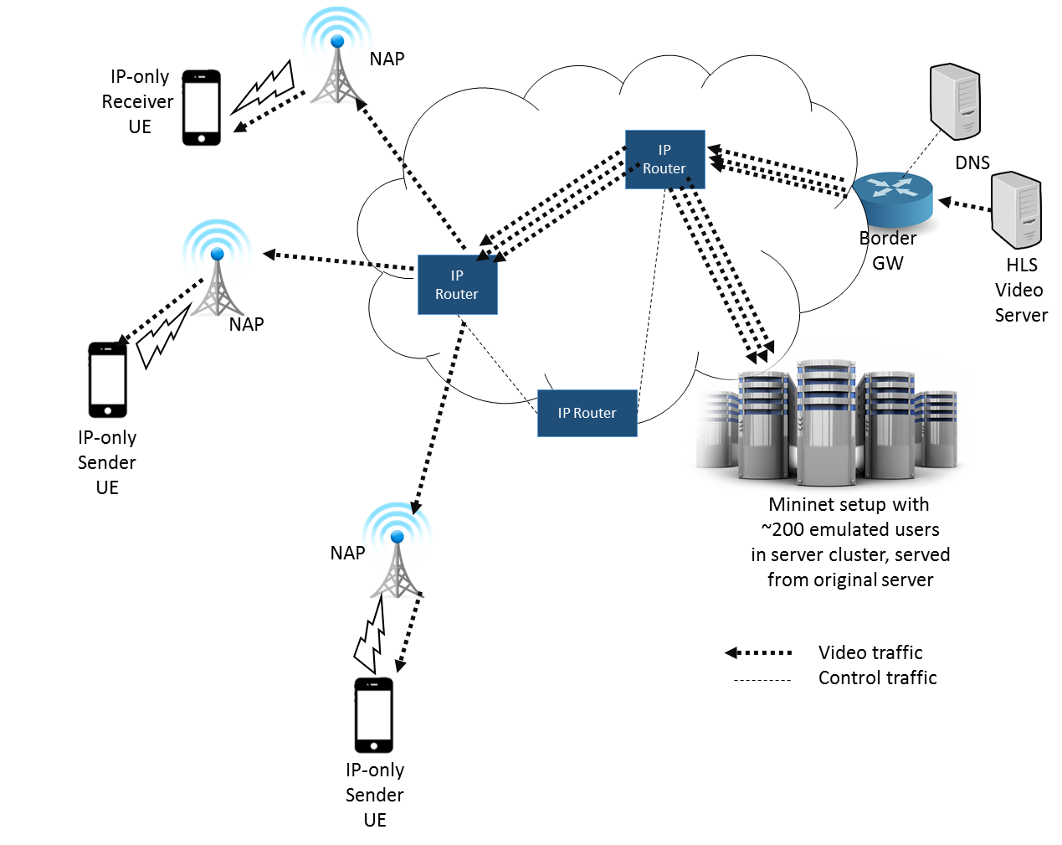
Figure 2 Original IP-based Routing with POC Deployment
The following procedures are used to measure the MEC Metrics that are measured in this PoC. For aggregated throughput, we measure the ratio of incoming bytes (server-facing NAP) at ingress vs outgoing bytes at all egresses (i.e., client-facing NAPs). This ratio is 1 in the optimal IP reference case, i.e., no packet losses in a well-connected network. We expect this ratio to be in the order of 10 to 15 for the PoC – the value is directly dependent on the number of clients being served. We provide an optional suppression of video requests towards the server. With that, the factor of improvement in the aggregated throughput above directly carries over as a server load reduction with the same factor. Latency improvement is expected when the surrogate of the video server near a cluster of users is activated. Standard latency reporting will be used for this measurement.

2.3 Additional information

