Title*: | Video Analytics
from Source*: | Nokia
Contact: | Dirk Lindemeier, Uwe Rauschenbach
input for Committee*: | MEC IEG
Contribution For*: | Decision | X
 | Discussion
 | Information
Submission date*: | 2016-07-19
Meeting & Allocation:
Relevant WI(s), or deliverable(s):

Decision/action requested: Please approve

ABSTRACT: This is an MEC PoC submission about a video analytics solution that leverages MEC for analyzing raw video streams of LTE-connected surveillance cameras and forwarding of relevant incidents to the local control room, under collaboration of Nokia, Vodafone Hutchison Australia and SeeTec.

PoC Proposal

1 PoC Project Details

1.1 PoC Project
PoC Number: 8
PoC Project Name: Video Analytics
PoC Project Host: Nokia

Short Description: Video Analytics is an end to end use case for providing video surveillance to cities, municipalities, and enterprises over an LTE network. MEC is used for analysing raw video streams from surveillance cameras connected over LTE, and for forwarding relevant incidents to the local control room.

1.2 PoC Team Members
 | Organisation name | ISG MEC participant  (yes/no) | Contact (Email) | PoC Point of Contact  (*) | Role (**) | PoC Components
1 | Nokia | Yes | Dirk Lindemeier  dirk.lindemeier@nokia.com  Uwe Rauschenbach  uwe.rauschenbach@nokia.com | X | Infrastructure Provider | MEC Server  End-to-end integration
2 | Vodafone Hutchison Australia | No | Easwaren Siva Easwaren.Siva@vodafone.com.au |  | Service Provider | LTE network
3 | SeeTec | No | Carsten Eckstein  carsten.eckstein@seetec.de |  | Application provider | Video analytics solution
(*) Identify the PoC Point of Contact with an X.
(**) The role will be network operator/service provider, infrastructure provider, application provider or other.

All the PoC Team members listed above declare that the information in this proposal is conformant to their plans at this date and commit to inform ETSI timely in case of changes in the PoC Team, scope or timeline.

1.3 PoC Project Scope

1.3.1 PoC Topics
PoC Topics identified in this clause need to be taken for the PoC Topic List identified by ISG MEC and publicly available in the MEC WIKI. PoC Teams addressing these topics commit to submit the expected contributions in a timely manner.

PoC Topic Code | PoC Topic Description | Related WG/WI | Expected Contribution | Target Date
PT01 | Demonstration of MEC Service Scenarios | MEC-IEG004 MEC service scenarios | High level guideline for how to implement the video stream analysis service scenario in a real network environment | Wk. 40
PT02 | MEC Architecture | MEC003 | Mapping of the PoC to the MEC Architecture and some feedback on the MEC architecture, if applicable | Wk. 48

1.3.2 Other topics in scope
List here any additional topic for which the PoC plans to provide input/feedback to the ISG MEC.
PoC Topic Code | PoC Topic Description | Related WG/WI | Expected Contribution | Target Date

A.1.4 PoC Project Milestones
PoC Milestone | Milestone description | Target Date | Additional Info
P.S | PoC Project Start | Wk 27
P.D1 | PoC Demo 1 at MEC Congress 2016 in Munich | Wk 38 | Responsible: Nokia
P.D2 | PoC Demo 2: public webinar | Wk 44 | Responsible: Nokia
P.C1 | PoC Contribution 1: Description of the contribution of this PoC to PoC Topics PT01 and PT02 (standalone contribution to IEG or part of P.R) | Wk 48 | Responsible: Nokia
P.R | PoC Report | Wk 48
P.E | PoC Project End | Wk 48

NOTE: Milestones need to be entered in chronological order.

1.5 Additional Details

A.2 PoC Technical Details

A.2.1 PoC Overview
As urbanization continues, cities need to become smarter, which includes leveraging information systems for lowering resource consumption, optimizing road traffic and public transportation systems, and improving the safety and wellbeing of their citizens. Many of these systems rely on extensive deployment of highly distributed sensors. The amount of data generated by these sensors can grow large and calls for efficient data processing strategies. The need for real time processing arises especially in the context of public safety, where incidents have to be detected as quickly as possible for initiating appropriate counter actions. Finally, sensor data handling is typically governed by tight requirements for data privacy, meaning that data needs to be appropriately protected and cannot be carried outside of the city perimeter.

LTE is an ideal technology for connecting sensors, and is being extended by new features that accommodate the requirements of Internet-of-Things (IoT) applications. MEC adds further capabilities, for example, processing sensor data close to the point of capture and breaking out traffic locally instead of running it through the centralized core network. Video Analytics, the proposed use case for PoC herein, exploits these capabilities to make LTE a viable option for operators to offer video surveillance as a service to cities and municipalities.

With MEC processing and analysis of high volume video streams from surveillance cameras is performed at secure network locations close to the cameras, which results in millisecond-level incident detection and significantly reduces upstream traffic inside the network. Also, the design of surveillance cameras can be simplified to pure sensors without onboard processing and storage capabilities, which reduces the camera’s direct cost – the single biggest cost contributor of a video surveillance deployment in general – and avoids regularly upgrading the camera’s software. Finally, MEC allows keeping all raw camera traffic local, which often is a regulatory requirement for public safety authorities that cannot be met with a traditional mobile network architecture.

A.2.2 PoC Architecture
This PoC consists of a macro-cellular eNodeB, MEC Server, Evolved Packet Core, video surveillance cameras, and a common video surveillance backend, as shown in Figure 1 below.

Objectives of the PoC are:
- Validate the video surveillance solution end-to-end
- Benchmark distributed analytics against centralized analytics in several technical and business dimensions
- Quantify network bandwidth savings before/after analytics

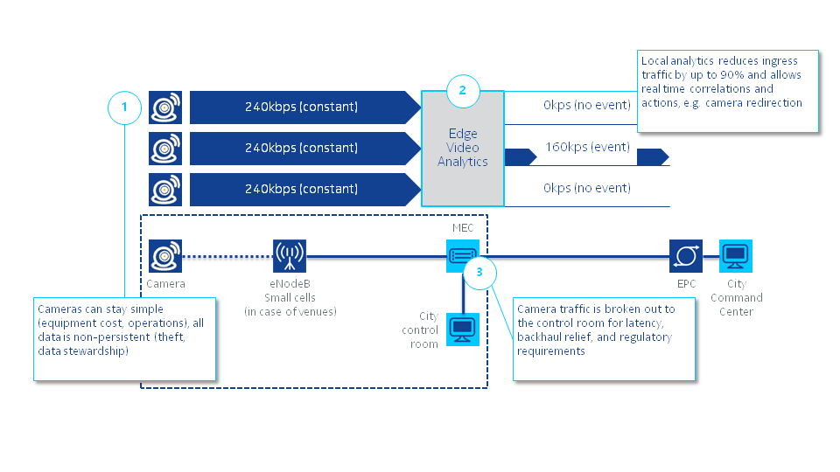
Figure 1: PoC architecture

As part of the PoC 2 video analytics use cases will be implemented:

- Object classification and counting: in this use case objects are classified and counted. This includes counting people that enter or leave a facility / room, count people in defined areas to detect congestion, count people in open areas, e.g. at events, and recognize people flows, e.g. in a mall or in a large retail store.

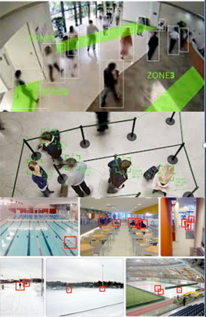

Figure 2: object classification and counting examples

- Object presence and absence: in this use case the addition or removal of an object is detected. This can be used for recognizing suspicious objects in sensitive areas, and to detect the theft of a valuable object.

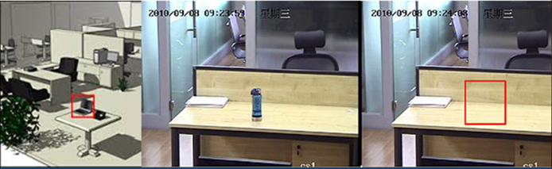

Figure 3: object presence and absence examples

The scope of the PoC also includes a simple alerting systems, which makes security staff aware of an incident in real time.

A.2.3 Additional information
The PoC is planned to be exhibited at the MEC Conference, September 20-22 2016 in Munich.

